THE ENERGY RITUAL WIKIUP

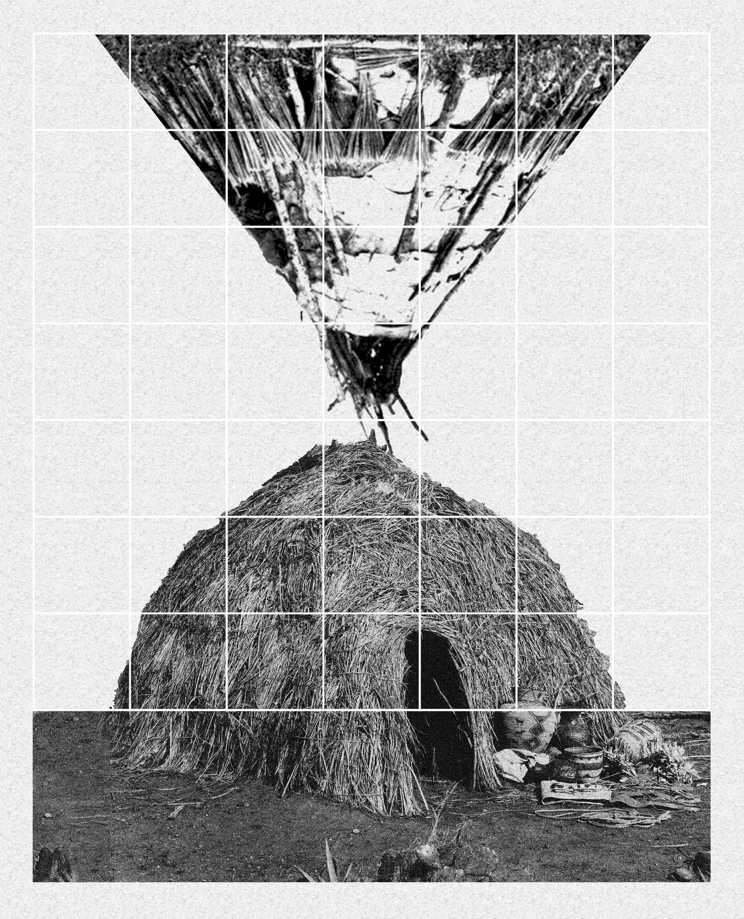

Written Narrative

Summary:
- Abstract: concept and story
- Main information:
  - activities and technology
  - materials and dimensions
- Cost estimate and prototype
- Environmental impact summary

1. Abstract: concept and story

The Energy Ritual Wikiup is an artistic pavilion that celebrates every day, from dawn to night, the ritual of transforming solar energy into energy for human creativity, telling the story of the Burning Man and the Pajute population.

It is a SHELTER, a place of meeting, exchange of ideas and celebration, but also a museum of the Burning Man Festival, an EXHIBITION PATH of knowledge and experimentation based on freedom of expression of Burning Man 10 principles, and no less a machine for the production and distribution of ENERGY and WATER.

Considering the entire area of the Fly Ranch, the project proposes an ARTISTIC AND TECHNOLOGICAL PARK developed on the still visible traces of the 1997 Burning Man site, in this place full of meaning.
The Energy Ritual Wikiup pavilion is a landmark. Together with the other energy and artistic artworks of the LAGI competition, it builds a village for artistic and technological creativity, the development of a culture of the territory and sustainability in an extraordinary landscape.

The reference of the project is taken from the tradition of the nomadic population of the Pajute, the historical custodians of the Nevada landscape, who have left us an archetype of construction of shelter in nature for the collective dwelling: the WIKIUP, temporary huts built through the interweaving and assembly of bundles of wood in shape of dome or pyramid.
From the memory of this building, The Energy Ritual Wikiup was developed; a pavilion that updates the meaning of the archetype of the Wikiup hut in our time, transforming it into a completely sustainable architecture for the community

2. Main information

The pavilion is composed of two overlapping elements that evoke wikiups: a wikiup-dome resting on pillars defines a covered and protected space for living in the broad sense of the artistic community and a wikiup-pyramid, upside down and suspended above, in the shape of a basket for capturing the sun's rays and transforming into electricity.
The two elements are contained in a structural frame grid which joins them in a scenographic energy transformation machine, with different possibilities of use.

2.1 activities and technology

SHELTER
The main theme of the project is the construction of an EXHIBITION ROUTE that tells the story of the Burning Man and the Fly Ranch.

The path develops in the structural grid on ramps and balconies arranged in a spiral to define an uphill and a downhill route that meet only on the last level.
Going up we are surrounded by an installation with information about the Burning Man and over the height of the dome we meet the Wikiup Energy Pyramid.
Thanks to its thin-film photovoltaic modules, the panels decorated with silk-screen printing become an artistic artifact: a large installation that tells the story of the Burning Man from 1986 to the present day, on the surfaces of its 100 panels, like a giant calendar of puppets, that builds a timeline.

At the top the paths join in the large terrace from which we can discover the beauty of the landscape, the relationships with the territory and the other pavilions of the park.
Before going down, we look out from the balcony onto the Wikiup Energy Pyramid, which reveals the whole story of the Burning Man in its panels flooded with sunlight.

At the end of the descent we pass under the Wikiup Dome, the real heart of the exhibition, where an artist's metal sculpture reproduces an "eternal" puppet of the Burning Man: a simulacrum in memory of 2020 edition.

In this place the community of visitors can experience different artistic activities during the day, but especially here every evening the ritual that celebrates the history of Burning Man takes place.

Under the darkness of the Wikiup Dome, perforated by a pattern of holes representing the constellations of the sky at the solstice of June 21, as in the first Burning Man, every night the energy collected during the day by the Wikiup Energy Pyramid is transformed into a show of artificial lights, flames and sounds.

ENERGY
The energy wikiup collects the sun's rays every day and transforms them into electricity. The structure is composed of a grid frame with modules of 150x80cm in which the photovoltaic panels with thin film amorphous silicone are arranged.
The panel is composed of a frame and solar cells, contained by two thin films of protective glass, decorated with representations and lettering.

Thanks to the evolution of the crystalline silicon-based photovoltaic module, these panels reach conversion efficiency peaks of 18% and an average of 12%, with excellent versatility and capacity even in suboptimal exposure conditions.

Considering the environmental context, the technical area of 134.4 square meters, and a yield of 0.18 MWh per year, this photovoltaic pyramid can produce 24.12 MWh of electricity per year, ensuring the working of the entire building and the distribution of surplus energy for visitors.

WATER
The Wikiup Energy Pyramid is also a huge funnel for collecting rainwater.
Thanks to its basket-shaped design, the water is conveyed to the center, descending the sculpture, to be collected in an underground tank, where it is purified and reused through a system of pumps and filters powered by the energy produced by photovoltaics. The purified water is available for the building's systems and for the irrigation of small vegetable gardens.

The Black Rock Desert region has an average rainfall of about 7.90 inches per year. In winter the average is 1.00 inches per month while in summer 0.40 inches.
Considering the collection area of about 56sqm the basket can collect in a year about 11.200 liter of water. During the summer months the collection is about 566 L while in the winter months of 1417 L

2.2 materials and dimensions
The pavilion has an external perimeter with a square base of 15.4 meters and rises in height up to 17.5 meters.

Its structure is built entirely of wood, a sustainable and reusable building material, easily found in the large forests on the California border.

The ground attachment has a lowered 2.5m module and a system of braced lozenge pillars to build a more solid base.

The structural grid is a double enclosure of frame walls, linked and passable in the space between the two (1.5 m).
The void inside the enclosure houses the two wikiups: the dome and the pyramid.
The grid is made by a frame structure, rigid in the constraints, but able to absorb the horizontal thrusts of the wind, thanks to the properties of wood.
The frame has a vertical rhythm of 1.5m and 3m of inter-storey, with horizontal bracing that works as a parapet and brise-soleil, rising for 5 floors.
There are mainly interlocking knots, exploiting the local tradition of woodworking, if necessary integrated by metal plates.
The dome of about 12m in diameter is made with a lamellar wood structure with lozenge ribbing design and a membrane that works as a shell. The rhomboidal ribs regularly distribute the thrusts to strengthen the structure keeping it light.

The dome rests on a system of radial wooden pillars founded in the ground and braced to the structure of the external cage.
The interior of the dome is plastered with raw earth and clay and painted blue to evoke the celestial vault, within holes that reproduce the design of the constellations are carved.

The inverted pyramid is composed of a main frame structure in laminated wood, hanging from 4 large beams arranged in a rhombus pattern on the last level. A light grid superstructure conforms to this geometry, with a sub-module for hooking the photovoltaic panels.

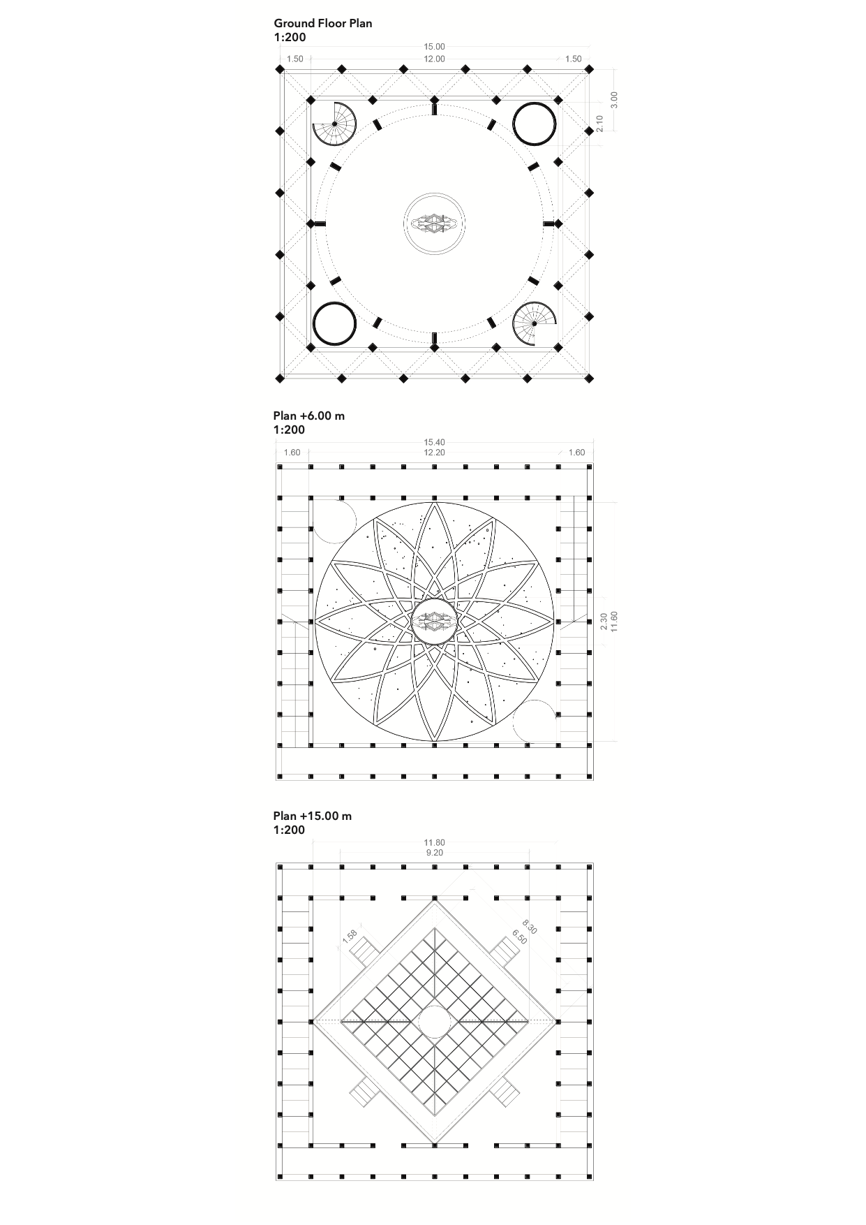

3. Cost estimate and prototype

The pavilion has a covered area of about 225 m². The walkable surface is about 800 m².
Calculating a construction cost for a rough wooden structure of about $325/sqm and a cost for the photovoltaic system of about $17,000, the cost of construction of the building could be around $300,000.

The prototype will be developed from a previous executive design to verify the technical and detailed solutions.

The development strategy plans 5 phases.
I) consultation of the project participants and the Fly Ranch community; identification of primary resources to be used and technological development companies located in the area.
II) analysis of the characteristics of the site area; transmission of project information; formation of participated project groups and division of tasks.
III) realization of the dry foundations for the wooden structure and the cistern and underground pipelines; realization of the prototype of the wooden cage modules; preparation of the elements for dry assembly.
IV) assembly of the parts starting from the basement perimeter; lifting of the dome and putting it in the correct position; prosecution of the raising of the structural cage, level by level; assembly in suspension of the inverted pyramid frame hanging from the structural cage; assembly of the technological elements, detail elements and plumbing equipment.
V) Testing of the pavilion with ignition of the energy systems.

The technical design will be started as soon as the competition is over in case of assignment.
The expected time for the execution of the 5 phases is 2/3 months.

4. Environmental impact summary

Considering the critical climatic conditions of the planet caused largely by the energy consumption policies of the twentieth century, the project seeks maximum sustainability and balance of Co2 emissions, through 5 main actions.

- Choice of wood as a natural building material with low environmental impact techniques, which does not require the use of additional materials and processes, thanks to the dry assembly guaranteed by the interlocking construction technique. Being already present in nature in the surrounding areas, wood does not consume energy for its production, but only in a very reduced way during the phases of finding and transformation for construction use.
- Reduction of CO2 production thanks to the use of local materials, widely available and therefore with short and limited transport.
- Study of a specific solution for the collection, conservation and purification for the reuse of rainwater, for the satisfaction of the entire plants of the building and for the irrigation of the gardens near the project site. Considering the collection area of about 56sqm, it is expected a collection of about 11,200 liters of water per year.
- Use of carbon-neutral energy generation technology to meet the energy needs of the building and balance its environmental impact. A system powered by photovoltaic panels with amorphous silicon thin film, conversion efficiency of 18% and an average of 12%. Considering the environmental context, the technical area of 134.4 square meters, and a yield of 0.18 MWh per year, the system can produce 24.12 MWh of electricity per year, ensuring the working of the entire building and the distribution of surplus energy for visitors.
- The building can be temporary or permanent with a very low maintenance cost. The entire pavilion is completely reversible and recyclable in its materials, and almost entirely removable and reusable in its construction and technological elements.

In conclusion, it can be stated with a synthetic forecast, which will have to be deepened in the final technical design phase of the project, that the project choices and actions undertaken will contribute significantly to the reduction of the environmental impact of the building, balancing the CO2 emissions of the construction process.

